COMP307 – Assignment 3

Obtaining Personally Identifiable Information through Internet Research

September 19, 2018 Ostap Hamarnyk – 300836326

Kevin Ma – 300867968

# Part A

Research the following sites for the respective information and fill in the last column of the table below:

|  |  |  |  |
| --- | --- | --- | --- |
| No | Site | Info | Yes/No, Comments |
| 1 | dogpile.com | Your name | Yes, the results mostly showing social media pages like Facebook, Instagram, YouTube, LinkedIn etc. |
| 2 | google.com | Your email | Yes, the search showed matched results where we provided our email. For example, the link to one of the projects on GitHub where we specified our email address |
| 3 | instantcheckmate.com | Follow online instructions | No, this website was built for American use only |
| 4 | alltheinternet.com | Your name with two keywords | No, the site showed sites with of people with the same first name but different last name. Also, the number of social media links is much less than the search results on the previous sites (dogpile.com & google.com) |
| 5 | zabasesearch.com | Your phone number | No, this website was built for American use only |
| 6 | Canada.ca | Your Name | No, there were no results that matched our names |

# Part B

## Question 1

According to conducted search on the given websites, we decided that there’s no risk of identity theft based on the information we got from those sites. Most of them contain our names, dates of birth and email address which is not enough to perform identity theft.

## Question 2

YouTube doesn’t take away your ownership rights when you post your video on their website. It is a common misunderstanding that video sharing sites and other social networking sites will own your videos once it is posted. According to YouTube Terms & Conditions, you as the owner of video will retain the ownership of your work once posted to YouTube. However, you grant to YouTube a non-exclusive, worldwide, perpetual license to re-distribute, re-publish, monetize, sub-licence and take many other actions to your video if they want. Basically, they have the same rights as you, but you remain the owner of the video.

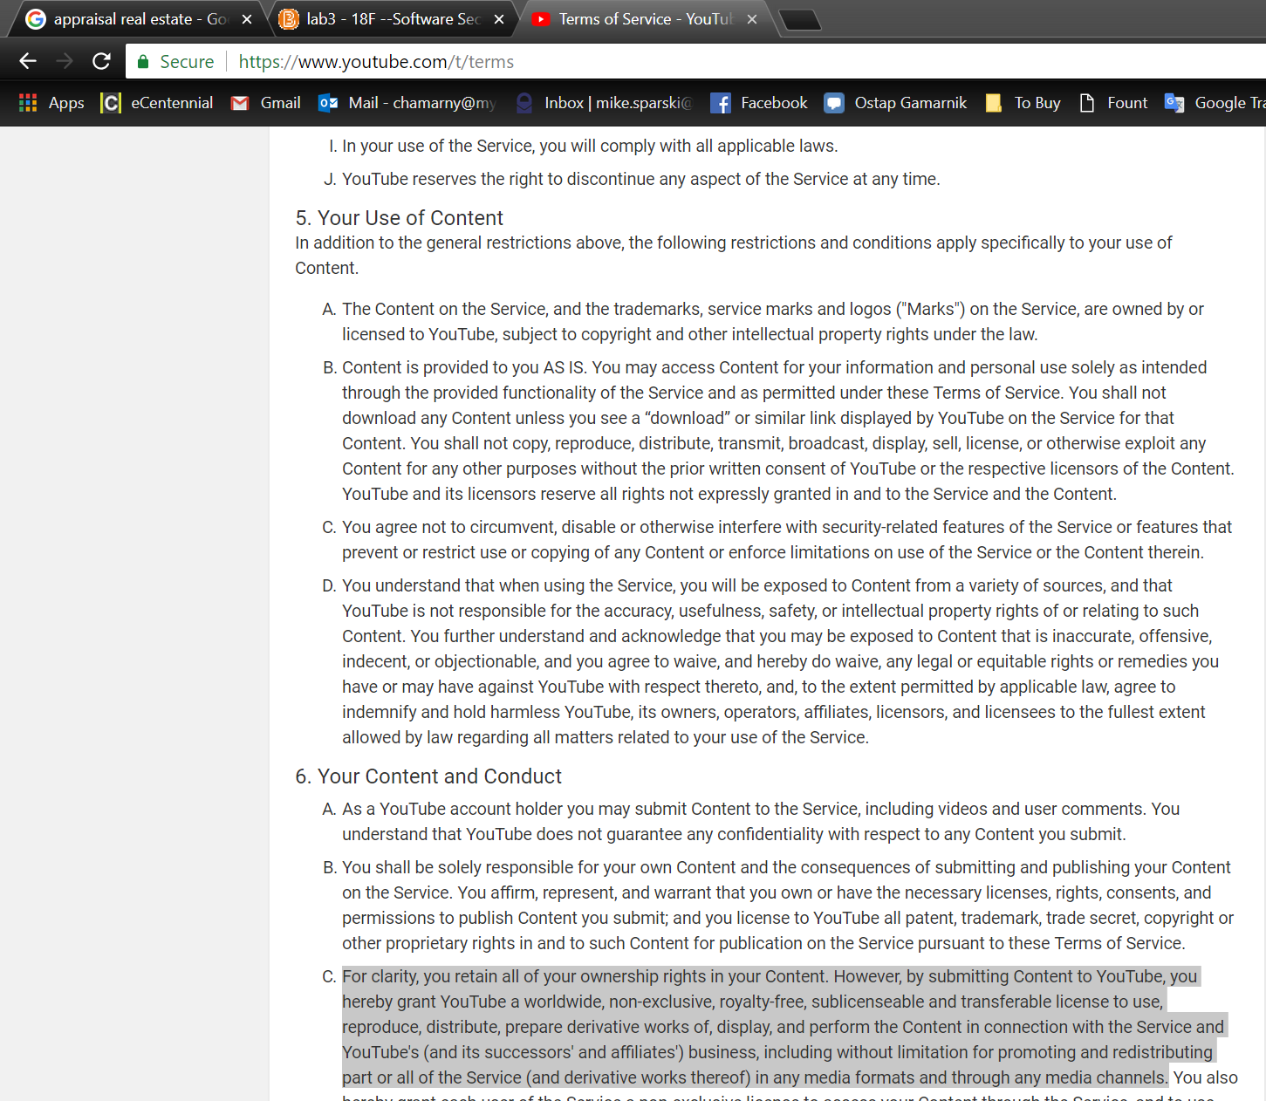

## Question 3

It is very important to keep personal life apart from career, especially on social media. Sometimes you might post a video or share a post that can affect your employee status in a bad way. Even if you don’t post anything, your friends can share moments that you wouldn’t like to be seen by your employer or business partners.